Software Project Management

LAB 5

1.

Cost:

* Cash flow

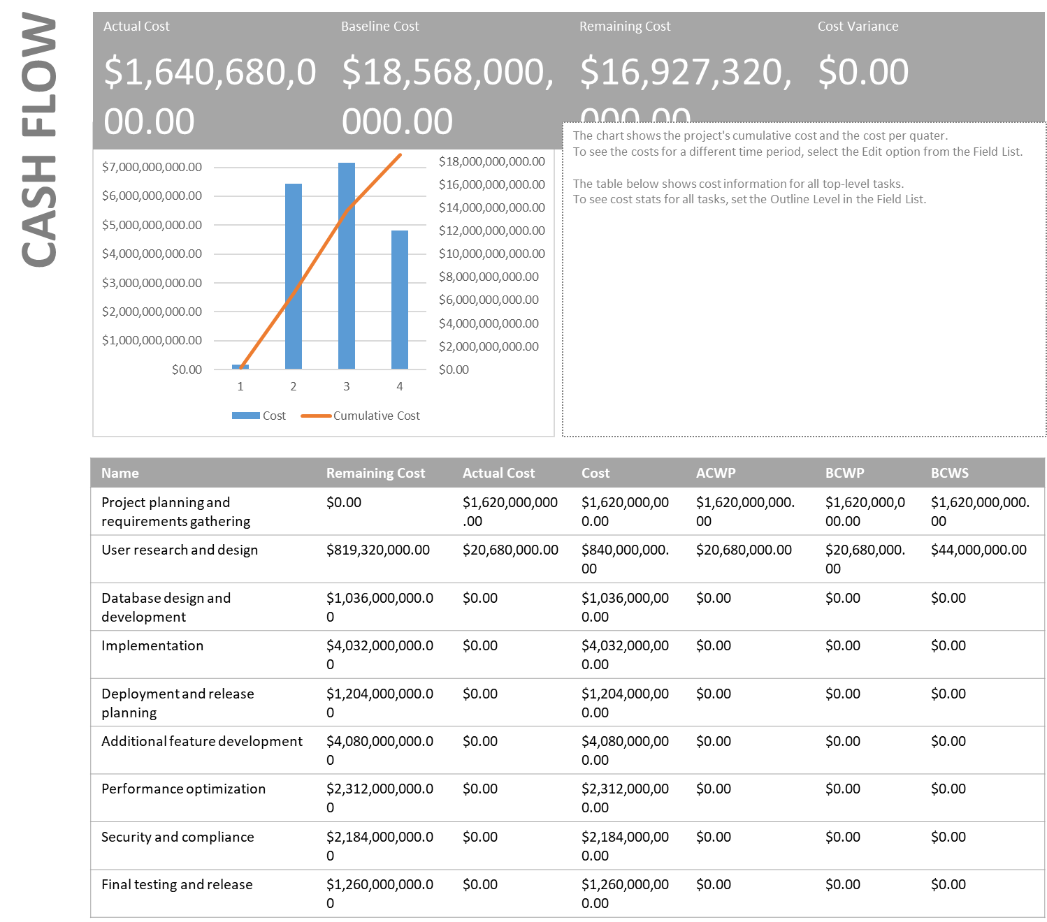

* Cost overruns

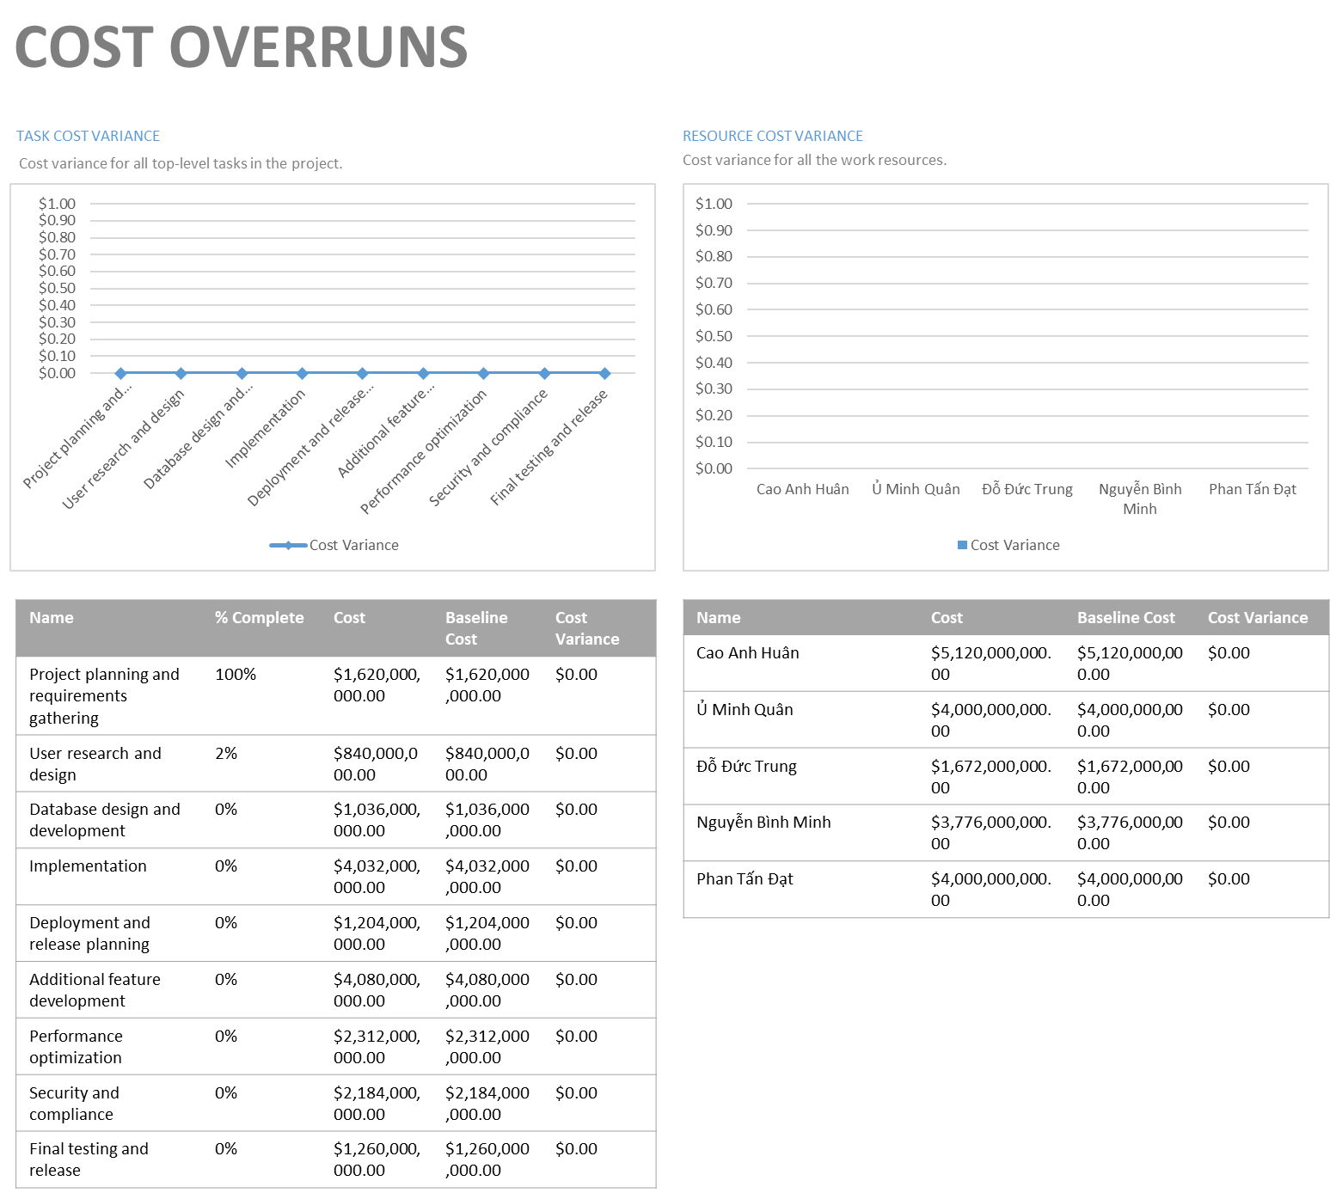

* Earned value

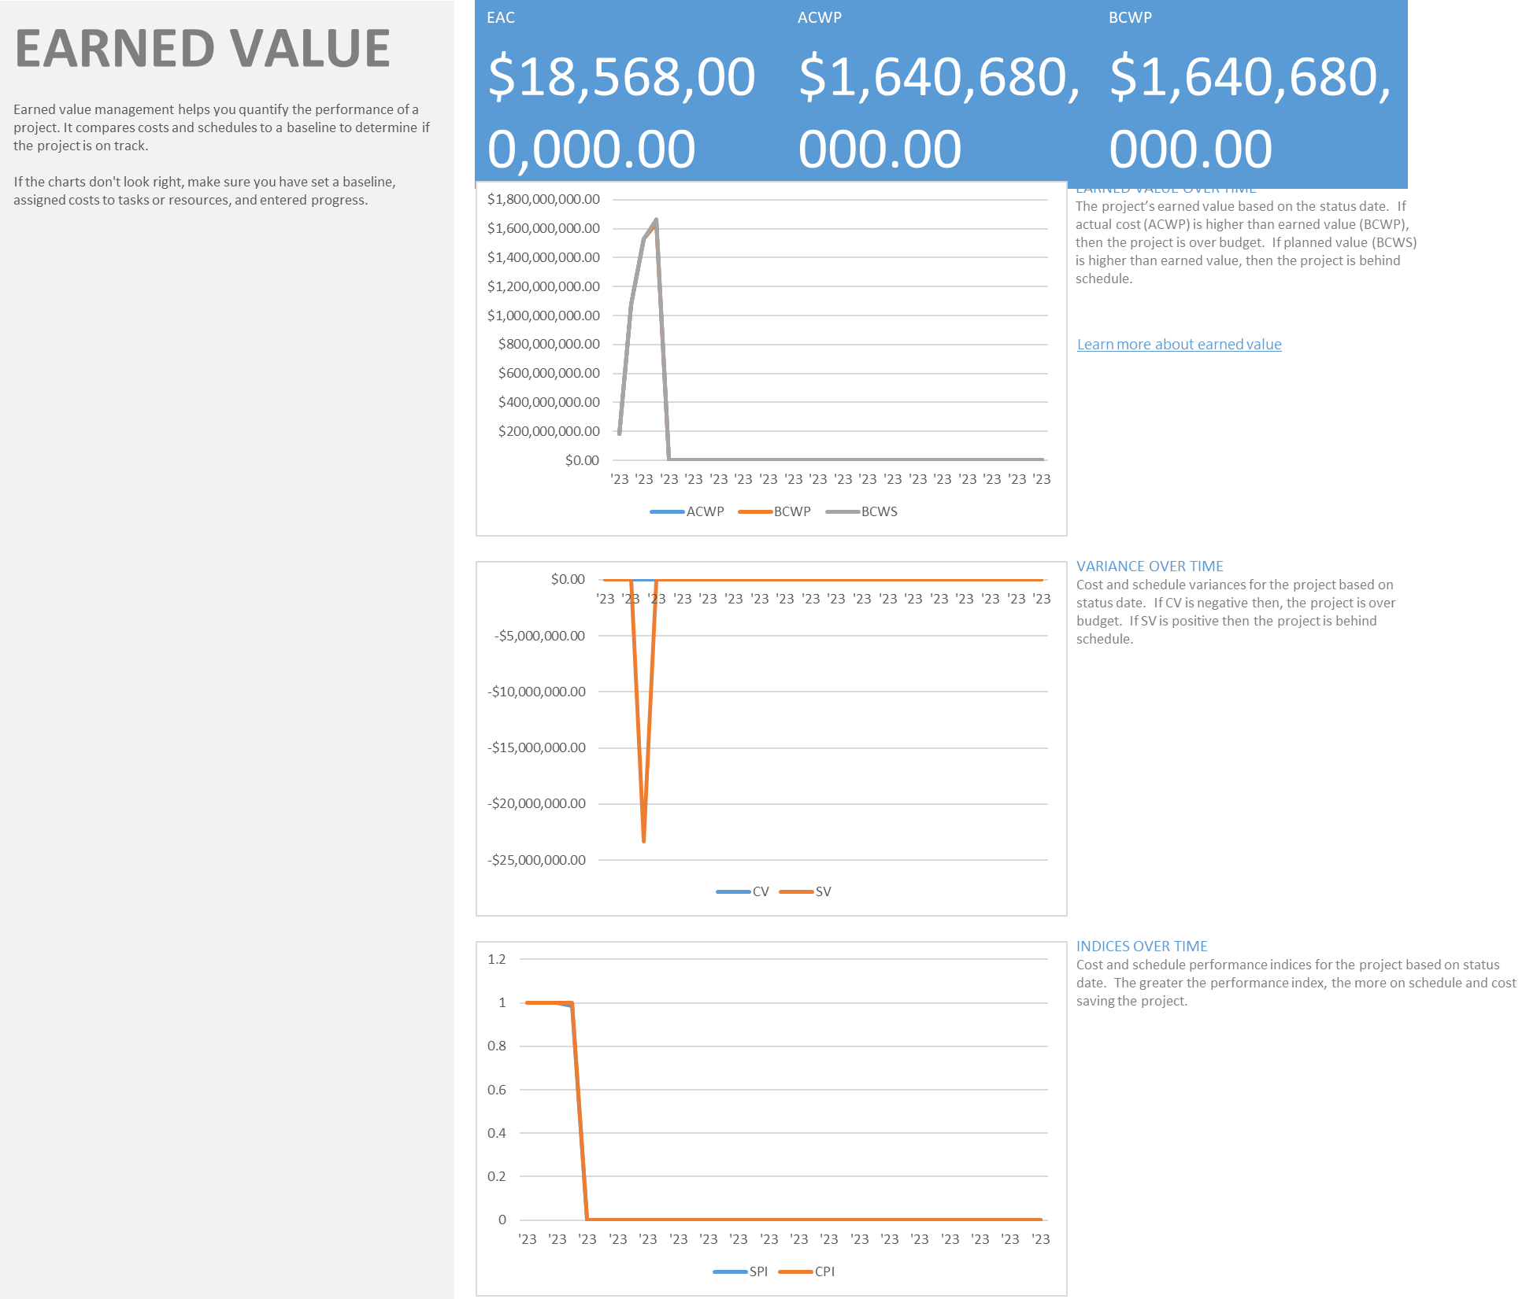

* Resource cost overview

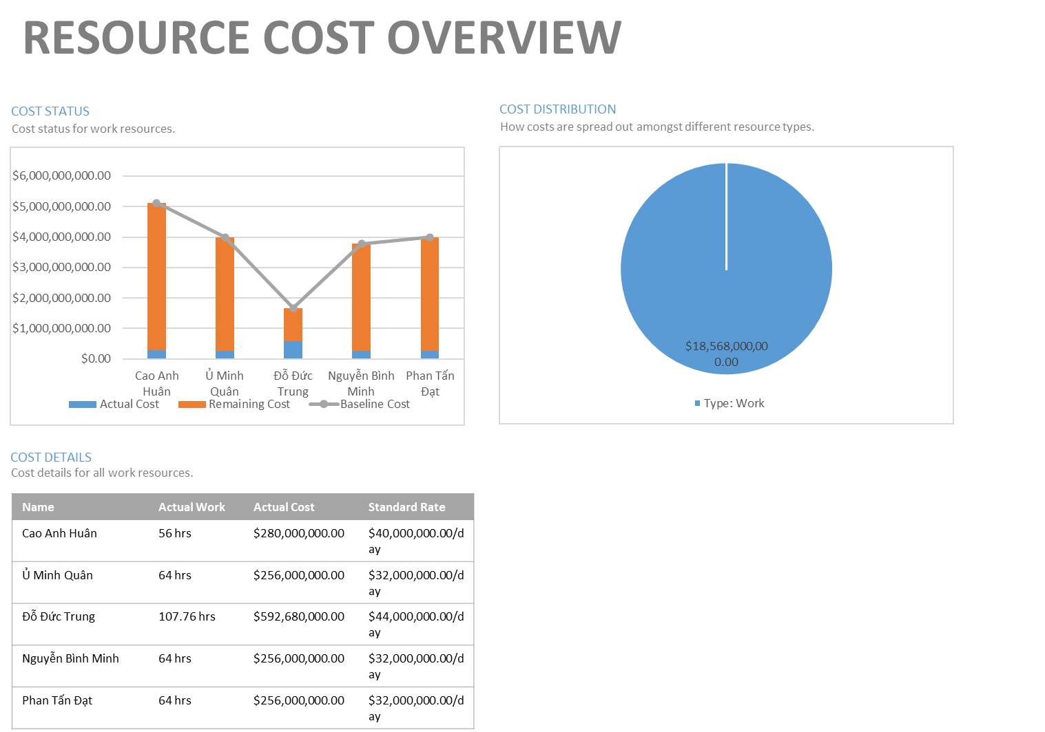

* Task cost overview

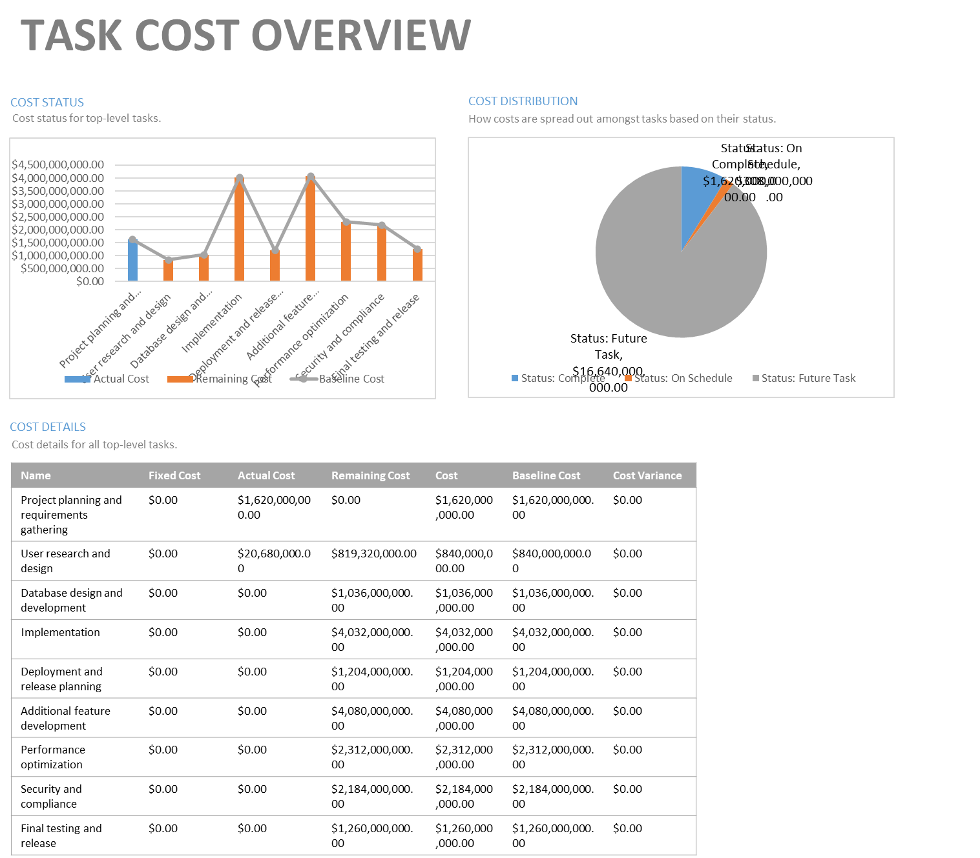

**Resource usage:**

* Overallocated Resources

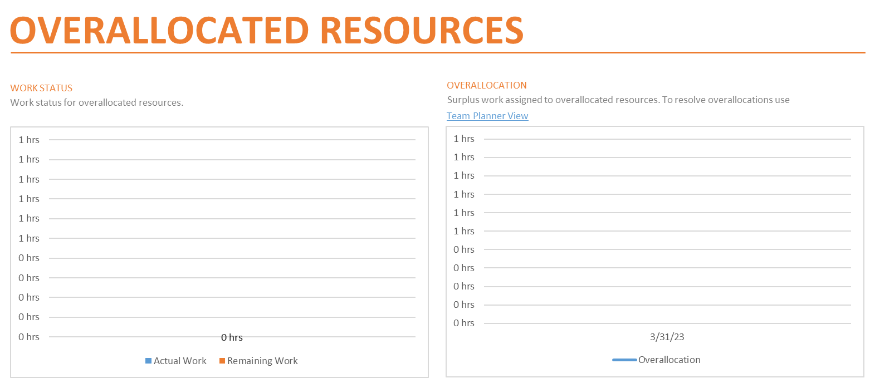

* Resource Overview

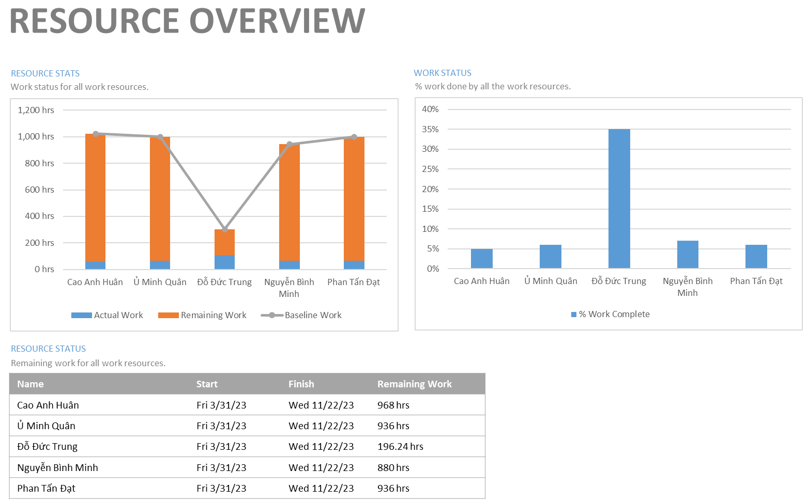

**Work of the project:**

* Critical Tasks

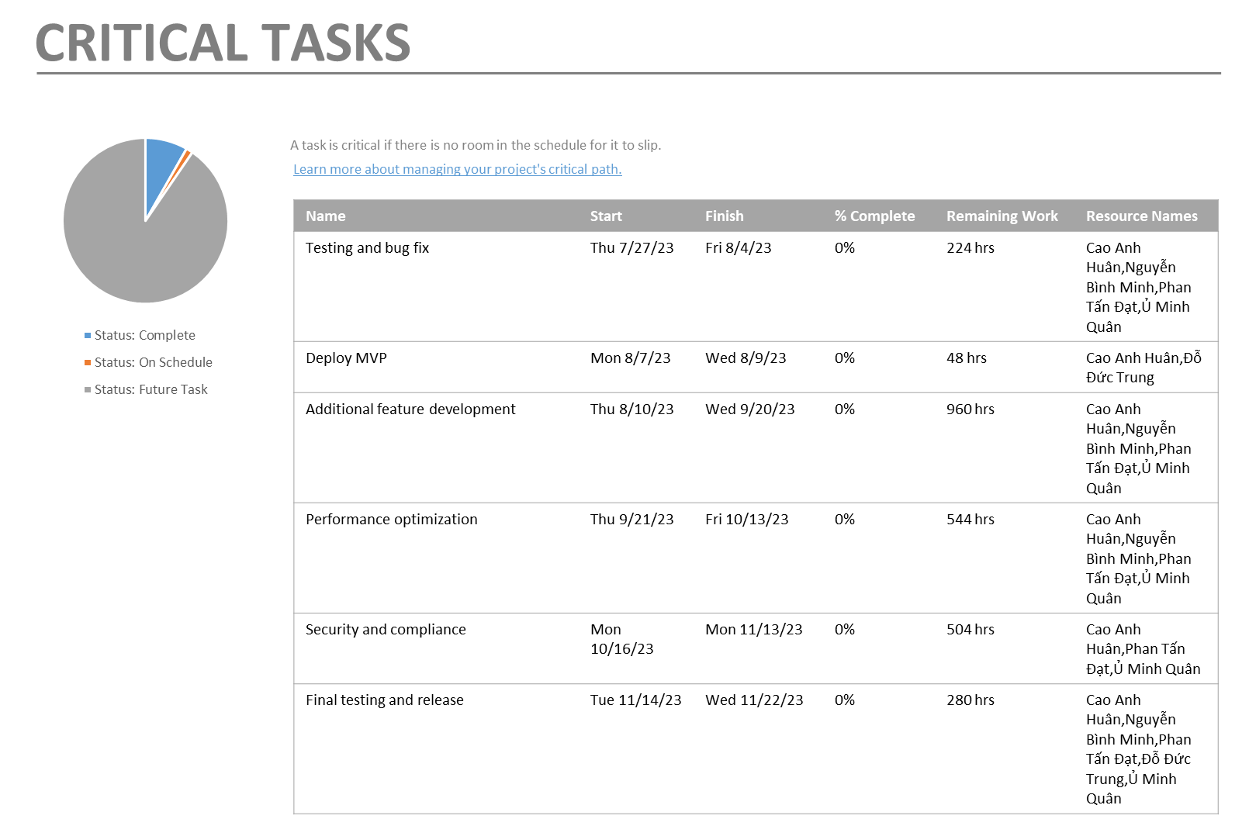

* Late Tasks

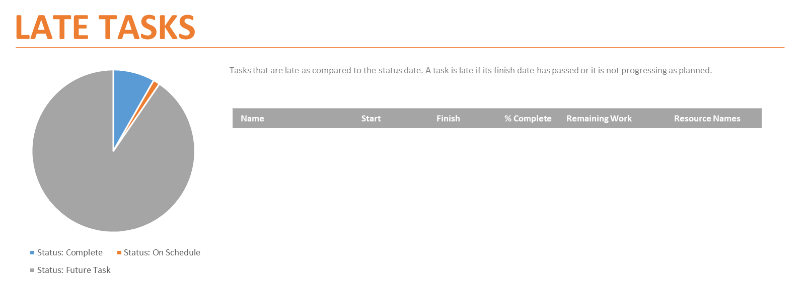

* Milestone report

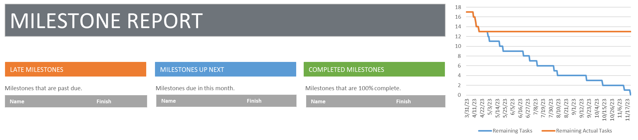

* Slipping Tasks

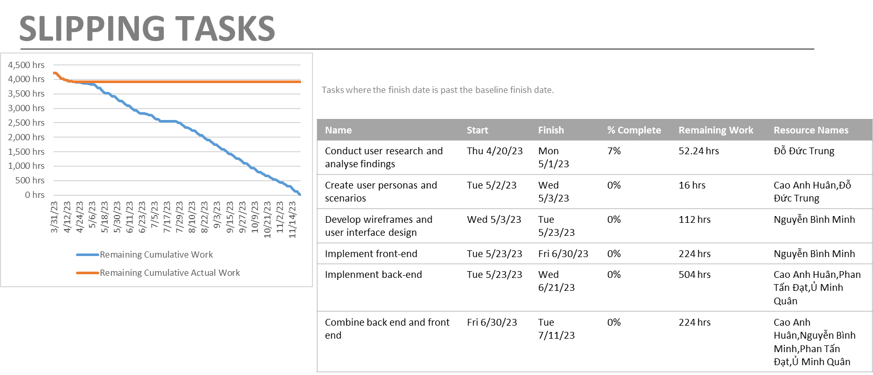

2 Printing and exported types of report

We can print the entire project / specific date / specific page if we want:

With many options:

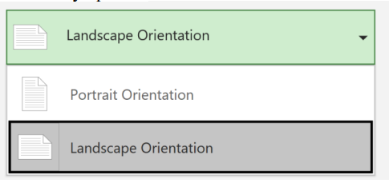

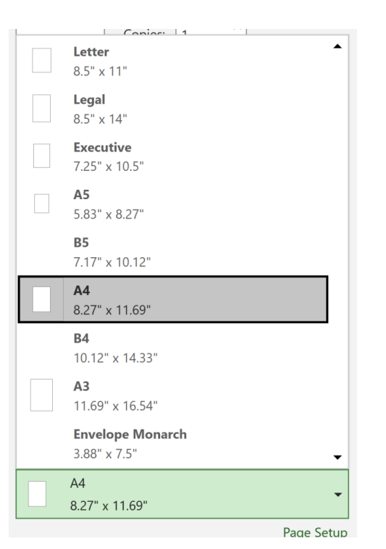

In addition, we can also export the project in the extension that we want using Save As:

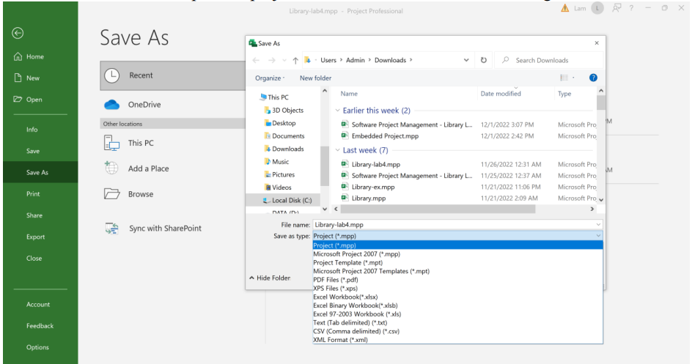

3. Make reports that represent summarization, meeting, progress, experience drawn from the project.

In general, our project is summarized like this:

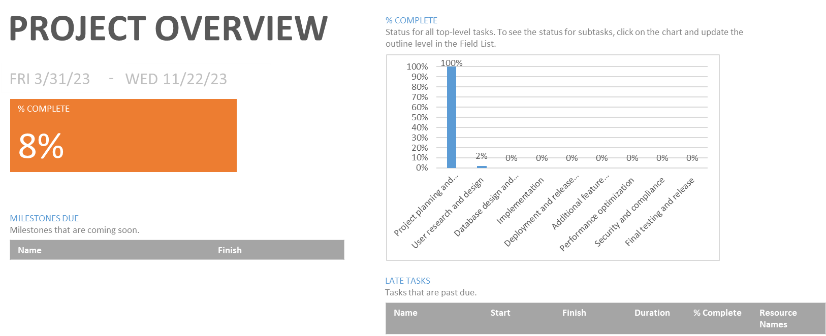

**Progress report:**

We have reports represent slipping task:



Critical path



Also we can view the report generated for our milestones:

Milestone report:

